A000-Afr-Egy-Ushabti-Dynasty 21-Third Intermediate Period-1069-945 BCE

**Case no.:**

**Accession Number:**

**Formal Label:**

**Display Description:**

**Dynasty XXI**, is the first Dynasty of the Egyptian Third Intermediate Period, 1069-945 BCE. After the reign of Ramesses III, a long, slow decline and fracturing of royal power in Egypt followed. **Dynasty XXI** pharaohs ruled from Tanis, where their political power emanated from, while High Priests of Amun at Thebes ruled Middle and Upper Egypt. Cultural decline that is obvious in this ushabti’s slapdash treatment exemplifies the collapse of the Late Bronze Age civilizations in the Near East and Eastern Mediterranean and Egypt.

**LC Classification: DT89**

**Date or Time Horizon:** Third Intermediate Period-1069-945 BCE

**Geographical Area:**

**Map:**

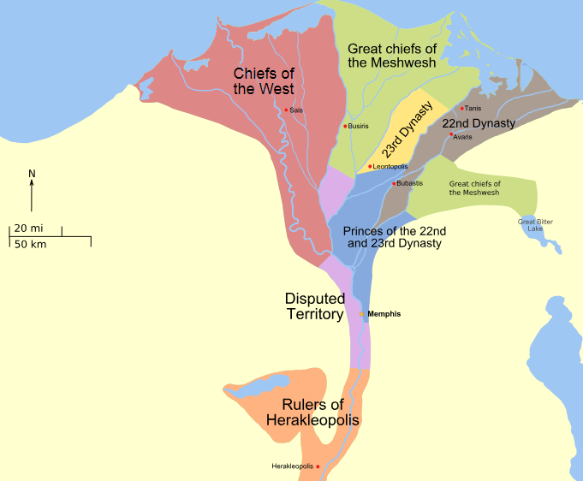 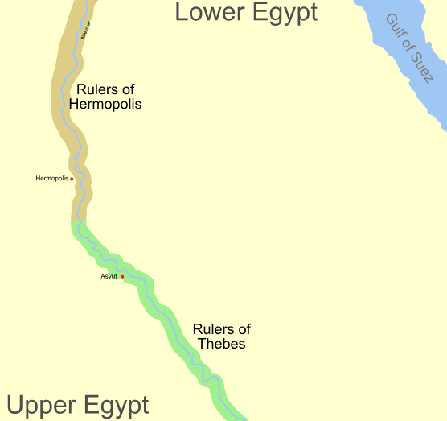

**The Third Intermediate period Political factions after https://upload.wikimedia.org/wikipedia/commons/7/75/Third_Intermediate_Period_map.svg**

**GPS coordinates:**

**Cultural Affiliation:** Egyptian Third Intermediate Period, 1069-945 BCE

**Media:** turquoise faience with black painted decoration

**Dimensions:** 3.83 in, 97.29 mm

**Weight: 3 3/8 oz, 98 gm**

**Condition: original**

**Provenance:**

**Discussion:**

**References:**

Kitchen, A. 2009.The third intermediate period in Egypt, 1100-650 B.C. Warminster: Aris & Phillips.